**Binary Search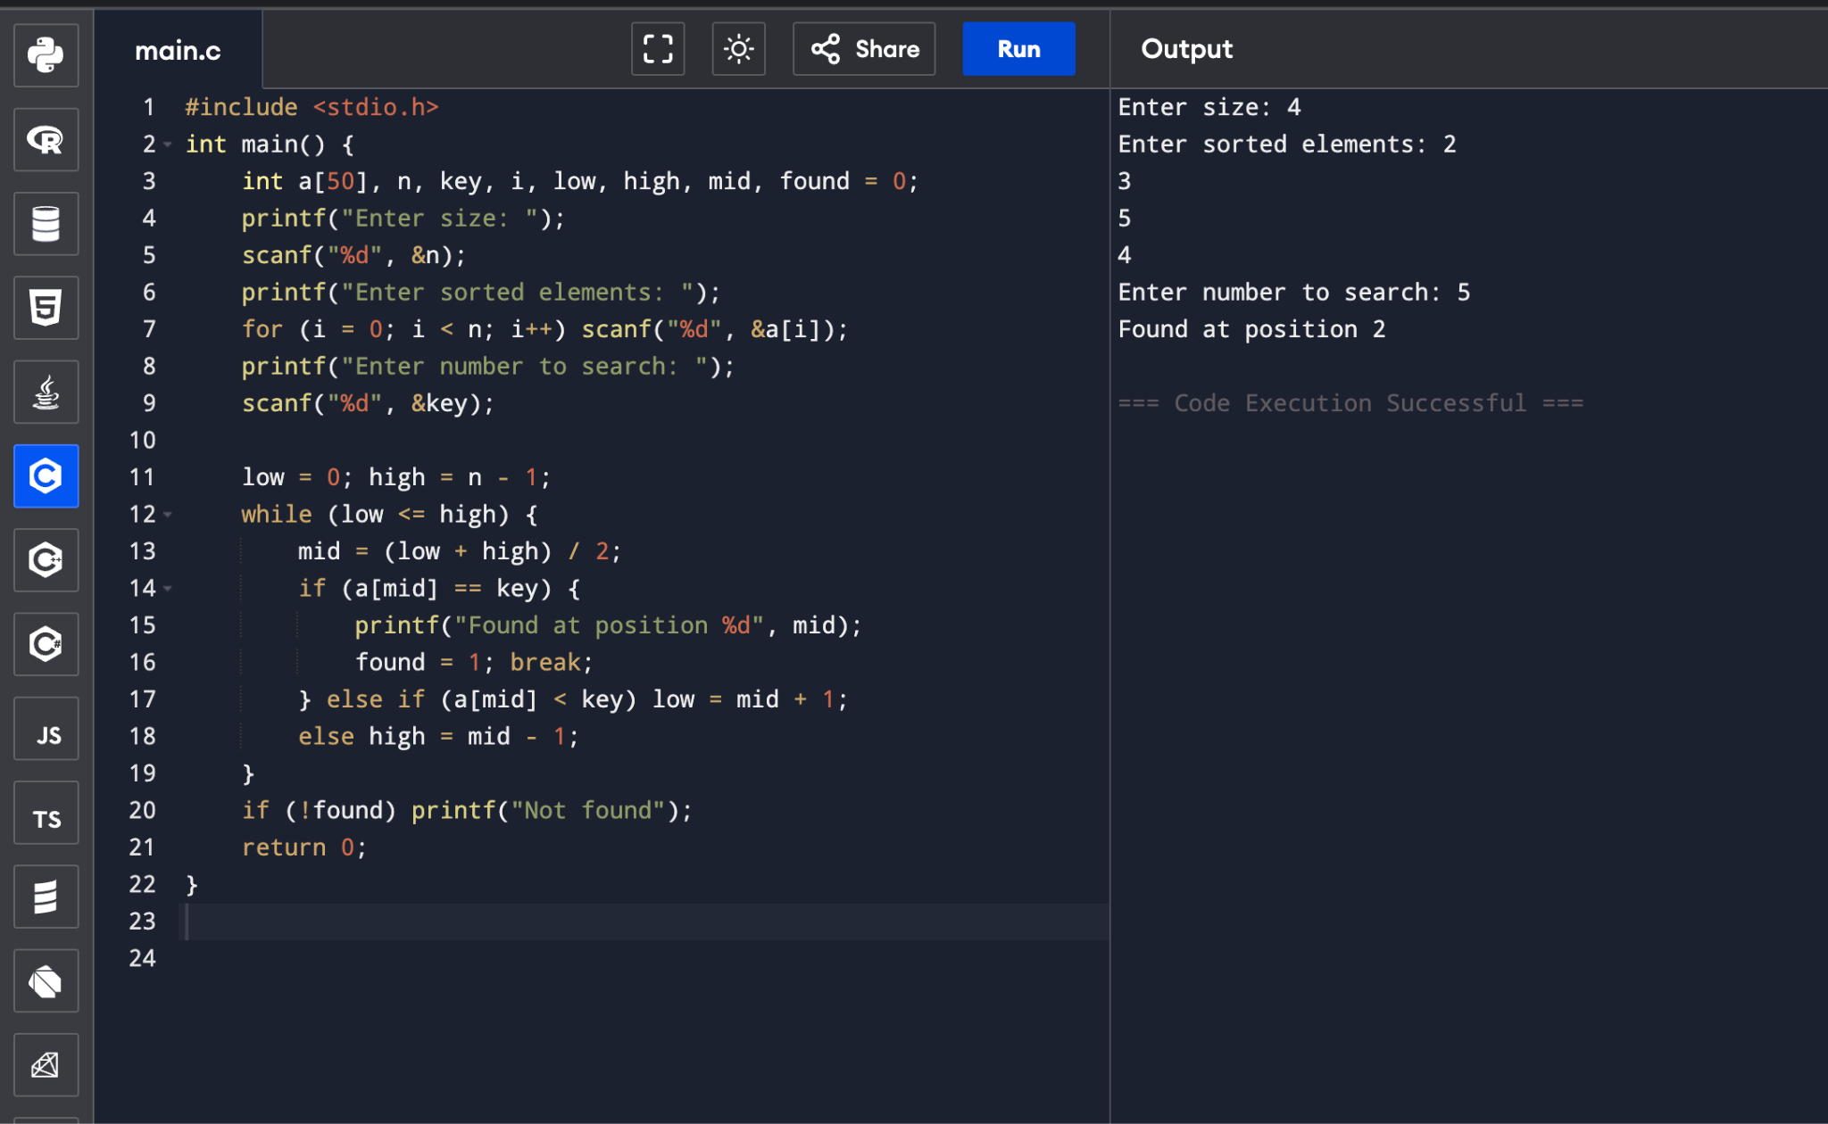**#include <stdio.h>

int main() {

int a[50], n, key, i, low, high, mid, found = 0;

printf("Enter size: ");

scanf("%d", &n);

printf("Enter sorted elements: ");

for (i = 0; i < n; i++) scanf("%d", &a[i]);

printf("Enter number to search: ");

scanf("%d", &key);

low = 0; high = n - 1;

while (low <= high) {

mid = (low + high) / 2;

if (a[mid] == key) {

printf("Found at position %d", mid);

found = 1; break;

} else if (a[mid] < key) low = mid + 1;

else high = mid - 1;

}

if (!found) printf("Not found");

return 0;

}